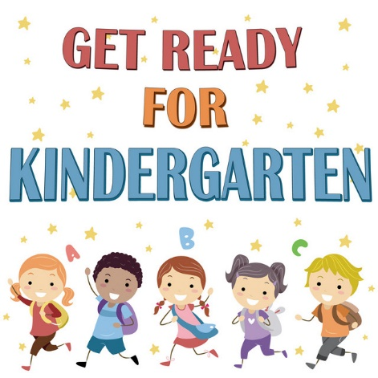

Edwin S. Richards Arts Based Curriculum School
Sibling Kindergarten Registration
December 1 – 16, 2022
9:00 am - 2:30 pm
Front Lobby of School

REGISTRATION REQUIREMENTS FOR ALL MISSION PUBLIC SCHOOLS:

Mission Public School District is located on the Traditional, Ancestral, Unceded, and Shared lands of the Stó:lō people, of Sq'éwlets, Leq'á:mel, Sema:th, Matheqwí and Qwó:ltl'el First Nations, peoples of this land since time immemorial.

✓ Children born in 2018 are eligible for Kindergarten in 2023-2024.
✓ Proof of age is required at time of registration: I.E. Birth Certificate, Passport, Permanent
Residence Card, BC Services Card (Photo Version Only), Aboriginal Status Card, Certificate of
Citizenship or Immigration Canada document.
• Please Note: The BC Care Card is not acceptable proof of age.
✓ Proof of Residency in BC:
• Parent’s Care Card (not student’s) / Parent’s BC Services Card (not student’s) /
Driver’s License / Municipal Tax Bill / Rental Agreement or Utility Bill

